3.5" External SATA Hard Disk ENCLOSURE

Simply Add Your Own 3.5" Hard Disk
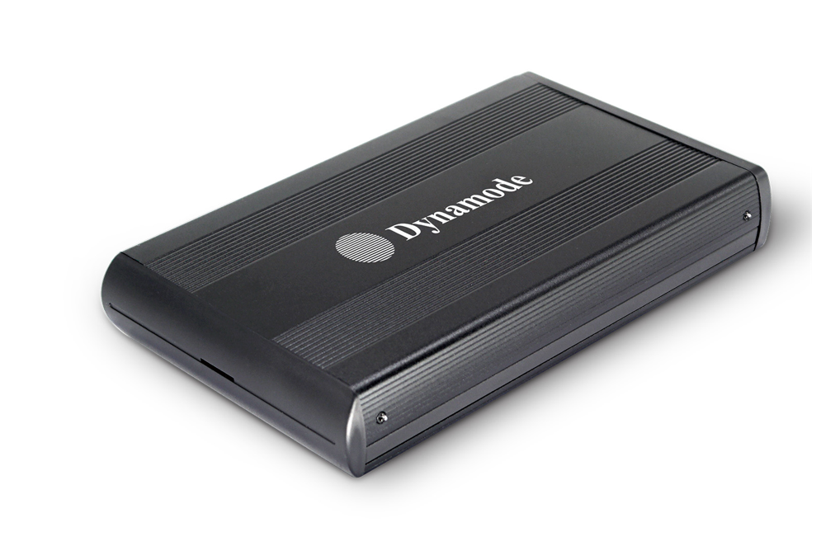

DESCRIPTION
Are you looking for a high-performance but fully backward compatible external hard disk enclosure for your desktop, notebook or other computing device? Do you need the extra data transfer performance that USB3.0 can give you for streaming movies without buffering or copying large digital images to and from your computer?
The USB-HD3.5S-3.0 is your ideal desktop, server or media centre storage enclosure. Featuring a SuperSpeed USB3.0 interface which transfers data around x10 quicker than standard USB2.0. And if your computer only has USB2.0 at the moment, no problem, the enclosure is fully backward compatible with USB2.0 if required,.
Easy for anyone to use, simply connect your existing 3.5" SATA interface hard disk, connect up the supplied USB3.0/USB2.0 data cable and start using it in a few minutes. Dynamode 3.5" SATA hard disk storage enclosure comes with an external power supply as standard.
Fully Plug and Play with leading Operating Systems including latest Windows ™ and Mac™ OS X.

FEATURES
> Backward compatible with USB2.0
> Stylish and portable aluminium design
> Ideal for your existing 3.5" SATA interfaced
hard disk drives
> Re-use your PC, Server or Mac hard disk and keep your data when you upgrade
> Plug'n Play for popular Operating Systems -
no drivers needed
> External PSU supplied
> Backup and restore your data at up to 5Gbps

SPECIFICATIONS
